**PROPOSED TITLE:**

SIGN LANGUAGE RECOGNITION SYSTEM

**FIELD OF INVENTION:**

**Assistive Technology:** Sign language to speech conversion technology can be integrated into various assistive devices, such as smartphones, tablets, or wearable devices, to help individuals who use sign language communicate more easily with those who don't understand sign language.

**Accessibility:** It can enhance accessibility in various settings, including educational institutions, workplaces, healthcare facilities, and public spaces, by allowing sign language users to communicate effectively with hearing individuals.

**Education:** Sign language to speech conversion technology can be a valuable tool in education, enabling deaf or hard of hearing students to participate more fully in mainstream classrooms. It can also assist teachers in delivering sign language instruction to hearing students.

**Interpreting Services:** Automated sign language to speech conversion can complement human sign language interpreters, providing a backup option when interpreters are not available or to assist in high-demand situations.

**Emergency Services:** In emergency situations, communication can be challenging for deaf or hard of hearing individuals. Sign language to speech conversion systems can be integrated into emergency response systems to facilitate communication.

**Communication Platforms:** These technologies can be integrated into video conferencing platforms, social media, and messaging apps to make online communication more inclusive for sign language users.

**Research and Development:** Ongoing research in this field focuses on improving the accuracy and usability of sign language recognition algorithms and developing more natural and responsive speech synthesis systems.

**BACKGROUND:**

Working on a sign language recognition system is driven by several important factors and motivations, each of which contributes to the development and advancement of this technology:

**1. Accessibility and Inclusion:** One of the primary reasons for developing sign language recognition systems is to promote accessibility and inclusion for the deaf and hard of hearing communities. These systems aim to bridge the communication gap between sign language users and those who primarily use spoken language. By enabling effective communication, these systems promote equal opportunities in education, employment, healthcare, and everyday interactions.

**2. Improved Communication:** Sign language is a rich and expressive mode of communication used by millions of people worldwide. Developing sign language recognition systems helps ensure that this community can fully participate in various aspects of life, from basic daily conversations to more complex interactions. It empowers individuals to express themselves effectively and be understood by a broader audience.

**3. Education:** Sign language recognition technology plays a crucial role in improving the educational experiences of deaf and hard of hearing students. It can be integrated into classrooms to facilitate communication between teachers and students, making education more accessible and inclusive. It also aids in language acquisition and literacy development.

**4. Employment Opportunities:** For deaf individuals, access to meaningful employment opportunities can be limited by communication barriers. Sign language recognition systems can enhance workplace communication, making it easier for employers and coworkers to interact with deaf or hard of hearing employees. This, in turn, can lead to increased job prospects and career advancement.

**5. Healthcare:** Effective communication is essential in healthcare settings to ensure that deaf or hard of hearing patients receive proper care and understand medical information. Sign language recognition systems can assist healthcare professionals in communicating with their patients, thus improving the quality of care and patient outcomes.

**6. Technological Advancements:** Advances in computer vision, machine learning, and natural language processing have opened up new possibilities for developing accurate and efficient sign language recognition systems. Researchers and developers are motivated by the challenge of applying these technologies to solve a real-world problem and improve the lives of individuals with communication barriers.

**7. Innovation and Research:** Sign language recognition systems are a fascinating area of research that combines multiple disciplines, including computer science, linguistics, and cognitive science. The development of such systems pushes the boundaries of technology and encourages innovation in AI and machine learning.

**8. Cultural Preservation:** Sign languages are an essential part of deaf culture and identity. By developing sign language recognition systems, there is an opportunity to contribute to the preservation and recognition of these unique languages and the cultures they represent.

**9. Legal and Ethical Obligations:** In many countries, there are legal and ethical obligations to ensure equal access and communication for individuals with disabilities, including those who use sign language. The development of sign language recognition technology helps fulfill these obligations.

**Fig.1 American Sign Language Hand Gesture**

**OBJECTIVE:**

We aim to build a virtual talking system without sensors for people who are in need, this concept is achieved by using image processing and human hand gesture input. This mainly helps people who can’t talk with other people.

The objective of the sign language recognition system with speech conversion, as described in your project, is multifaceted and aims to address several important goals and challenges:

1. The primary objective of the system is to facilitate communication for speech-impaired individuals who rely on sign language as their primary means of expression. By recognizing and translating sign language gestures into spoken language and text, the system enables these individuals to communicate more effectively with those who do not understand sign language.

2. The system seeks to enhance accessibility and promote inclusion for individuals with speech impairments. It aims to break down communication barriers, enabling speech-impaired individuals to participate more fully in various aspects of life, including education, employment, healthcare, and social interactions.

3. The project's core objective is to develop a robust sign language recognition system capable of accurately interpreting static hand gestures representing 26 English alphabets (A-Z) and 10 digits (0-9). This involves training Deep Neural Networks (DNNs) using various architectures and configurations to achieve high classification accuracy.

4. Another central objective is the conversion of recognized sign language gestures into spoken language. This involves initiating voice media through the system when the input image matches with the predefined dataset. This real-time speech synthesis enhances the user experience and makes communication more natural.

5. The project focuses on optimizing the performance of the neural network models through training, testing, and experimenting with various architectures like LeNet-5 and MobileNetV2. Achieving high accuracy in gesture recognition is crucial for the system's effectiveness.

6. The creation of a web application using Django Rest Frameworks serves the objective of making the system accessible and user-friendly. It provides a practical platform for users to interact with the technology using live camera input.

**FIGURES AND FLOW CHARTS:**

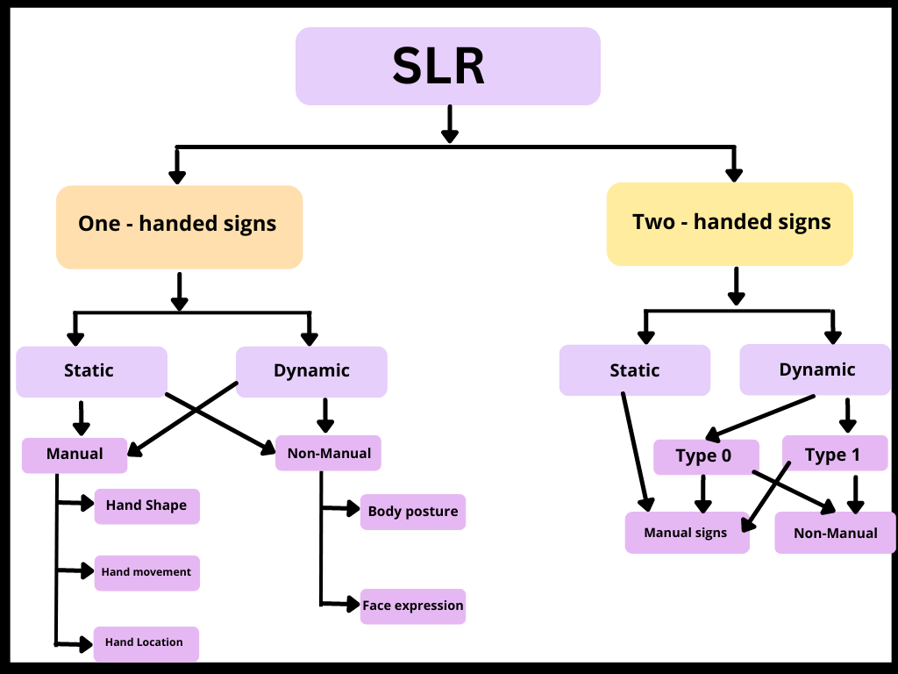

Fig.1.Hierarchy of signs[1]

**Fig.3. Methodology Data Flow Diagram of Sign Language Recognition System**

Sign Language to Speech

**Fig.4. DFD Level 1 of Sign Language Recognition System**

**Fig.5. DFD Level 2 of Sign Language Recognition System**

**CLAIMS:**

A sensorless sign language recognition system comprising a novel model designed to facilitate seamless communication for individuals with speech and vocal disabilities.

It provides a two-way communication channel, enabling efficient interaction between individuals with speech and vocal disabilities and those without, thereby fostering inclusivity in communication.

The sign language recognition system serves the societal goal of enhancing communication accessibility for deaf and mute individuals by leveraging an image-based approach for sign language recognition, thereby contributing to the overall welfare of the community.

It is tailored to serve as an accessible communication tool for the deaf and mute population, designed to be integrated into various platforms and devices, with the capability to operate on minimal system resources, ultimately leading to near-zero cost implementation.

The sign language and recognition system has cost-effectiveness and hence, makes it a viable and affordable solution for addressing the communication needs of the deaf and mute individuals in diverse settings.

**APPARATUS/TECHNOLOGY USED:**

* **Image Recognition:-** Image recognition is a mechanism used to identify an object within an image and to classify it in a specific category, based on the way human people recognize objects within different sets of images.
* **Open CV:-** OpenCV is the huge open-source library for the computer vision, machine learning, and image processing and now it plays a major role in real-time operation which is very important in today’s systems. By using it, one can process images and videos to identify objects, faces, or even handwriting of a human.
* **Numpy:-** NumPy is a library for the Python programming language, adding support for large, multi-dimensional arrays and matrices, along with a large collection of high-level mathematical functions to operate on these arrays.
* **Keras:-** Keras is an open-source library that provides a Python interface for artificial neural networks. Keras acts as an interface for the TensorFlow library.

**ABSTRACT:**

Every day we see many people who have disabilities like being deaf, dumb, blind etc. They face difficulty interacting with others.Sign language is the only tool of communication for the person who is not able to speak or hear anything. Sign language is a boon for the physically challenged people to express their thoughts and emotion. In this work, a novel scheme of sign language recognition has been proposed for identifying the alphabets and gestures in sign language. With the help of computer vision and neural networks we can detect the signs and give the respective text output.

Previously developed techniques are all sensors based and they didn’t give the general solution. Now technology is developed to the point that AI can help to solve this problem. The proposed system would be a real time system wherein live sign gestures would be processed using image processing and then converted into speech. Machine Learning algorithms will be used to train on the data set. The purpose of the system is to improve the existing system in this area in terms of response time and accuracy with the use of efficient algorithms, high quality data sets and better sensors. The existing systems have been able to recognize gestures with high latency as it uses only image processing. In our project we aim to develop a cognitive system which would be responsive and robust so as to be used in day to day applications by hearing and speech disabled people.

**END USERS:**

* **Deaf and Hard of Hearing Individuals:** One of the primary target audiences is the deaf and hard of hearing community. Sign language recognition systems can assist them in communication and interaction with others.
* **Interpreters and Translators:** Sign language interpreters and translators may use the system to enhance their accuracy and efficiency when interpreting sign language.
* **Educational Institutions:** Schools and universities that have deaf or hard of hearing students may use these systems to improve the accessibility of education.
* **Healthcare Providers:** Medical professionals can benefit from sign language recognition systems when communicating with deaf or hard of hearing patients.
* **Customer Service and Support Centers:** Organizations with customer service or support departments may implement sign language recognition to assist customers who communicate through sign language.
* **Accessibility and Inclusion Advocates:** Individuals or groups advocating for accessibility and inclusion for the deaf and hard of hearing may be interested in promoting or using such systems.
* **Technology Developers and Researchers:** Researchers and developers in the field of sign language recognition technology may be the audience for patents, research papers, or conferences related to this technology.
* **Communication Device Manufacturers:** Companies that produce communication devices may integrate sign language recognition into their products to cater to a wider audience.
* **International Audiences:** Depending on the system's language support and capabilities, it may target international audiences where different sign languages are used.

**ADVANTAGES:**

**Sign language recognition systems offer several advantages, both for individuals who use sign language and for broader society. Here are some key advantages:**

* **Improved Communication for the Deaf and Hard of Hearing:** Sign language recognition systems provide a means for deaf and hard of hearing individuals to communicate more effectively with others, bridging the communication gap.
* **Increased Accessibility:** These systems enhance accessibility in various contexts, such as education, healthcare, customer service, and public spaces, making services and information more inclusive.
* **Efficiency:** Sign language recognition can make communication more efficient by converting sign language into text or spoken language, allowing for quicker interactions.
* **Support for Sign Language Interpreters:** Interpreters can use these systems as tools to assist in their work, improving the accuracy and speed of sign language interpretation.
* **Independent Living:** Deaf individuals can gain more independence in daily tasks, such as ordering food, making appointments, or accessing information, without relying on sign language interpreters.
* **Education:** Sign language recognition systems can be integrated into educational settings to support deaf students' learning, making content more accessible and interactive.
* **Healthcare Communication:** These systems aid healthcare providers in communicating with deaf or hard of hearing patients, ensuring they receive appropriate medical care.
* **Customer Service:** Businesses can enhance customer service by offering sign language support, creating a more inclusive and accommodating environment.
* **Research and Development:** Sign language recognition systems contribute to advancements in technology and artificial intelligence, promoting research and innovation in the field.

**SUMMARY AND CONCLUSION:**

* **Summary:**

The sign language recognition system is a technology designed to interpret and understand sign language gestures made by individuals who are deaf or hard of hearing. This system typically involves the use of cameras and machine learning algorithms to translate sign language into text or speech, making communication more accessible for the deaf and hard of hearing community.

* **Conclusions:**

-Accessibility Improvement: Sign language recognition systems have the potential to significantly improve accessibility for deaf and hard of hearing individuals by bridging the communication gap between sign language users and those who do not understand sign language.

-Technological Advancements: Advances in computer vision and machine learning have greatly enhanced the accuracy and reliability of sign language recognition systems over the years.

-Real-world Applications: These systems find practical applications in various sectors, including education, healthcare, customer service, and accessibility services, where they enable better communication between hearing and non-hearing individuals.

-Challenges Remain: Despite progress, challenges such as recognizing different sign language dialects and complex hand movements, as well as the need for continuous improvement in accuracy, remain for sign language recognition systems.

-Future Development: Continued research and development in sign language recognition technology, including the integration of more natural and intuitive user interfaces, will further enhance its usability and impact.

In conclusion, sign language recognition systems have made significant strides in improving accessibility and communication for the deaf and hard of hearing community. However, ongoing efforts are needed to address challenges and ensure that these systems are inclusive, accurate, and ethically sound.